Chapter 9 Costume & Adornment

Development of Chinese Costume

Origin of Chinese Costume
- people covered themselves with natural materials like leaves, grasses and animal furs
- with the invention of sewing, better clothes are made possible
- assists in people’s adaptability, resulting in the expansion of territories and the increase in productivity
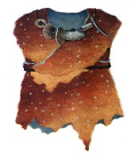
Clothes in Zhou dynasty
- rules of clothes etiquette started in the Zhou dynasty
- sacrificial attire, court attire, army uniform, mourning attire and wedding attire are classified
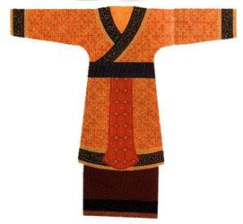
Clothes in Spring and Autumn and Warring States
- in different styles
- different states use different styles of clothes to display their
state identity
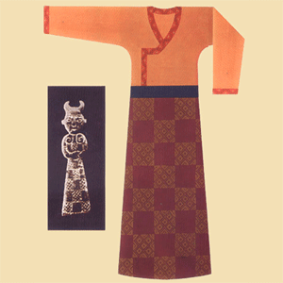
Clothes in Qin and Han Dynasties
- style of clothes is changed dramatically
- mostly in black in Qin dynasty
- mostly in red in Han dynasty
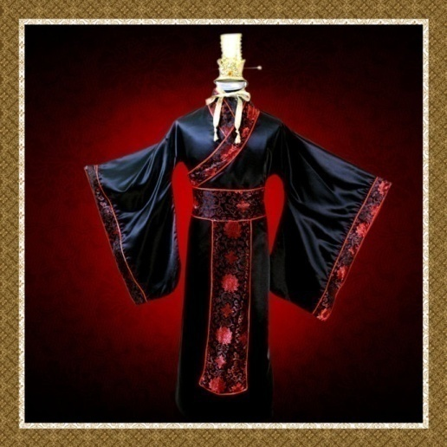
Clothes in Wei, Jin, and Southern and Northern dynasties
- classified into two categories: the folk costume and the official costume
- folk costume: close-fitting, round-collared and vented
- official costume: in formal style
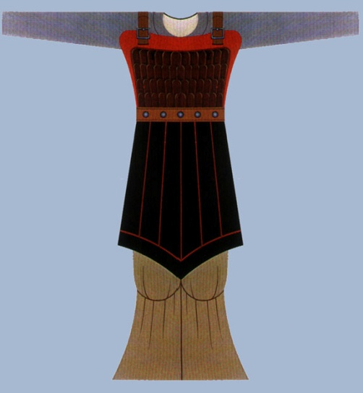
Clothes in Tang Dynasty
- the styles became more varied as the society was more
open to the outside world
- women didn’t have to abide by the traditional dress code
- parts of their bodies can be exposed
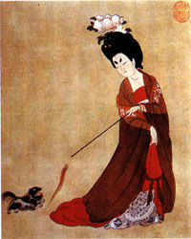
Clothes in Song Dynasty
- simple and natural
- during the period, casual wear appeared
- fashionable for women to bind their feet
- foot binding didn’t die out until in the early 20th century
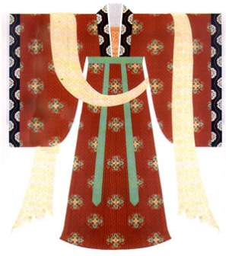
Clothes in Yuan Dynasty
- simple and unadorned
- combines Mongolian and Han influences
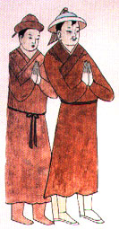
Clothes in Ming Dyansty
- buttons in the front replaced the band knots that had been in use for several thousands years
- decorated with various striking adornments made of gold, jade, pearl, etc
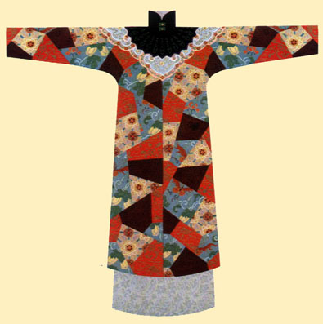
Clothes in Qing Dynasty
- there was no limitation to one style and natural beauty
was advocated
- elegant and poised
- people’s status is reflected in their clothes
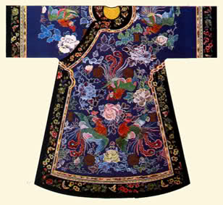
Clothes in Modern Day
- influenced by Western costumes
- traditional elements are added into modern clothes
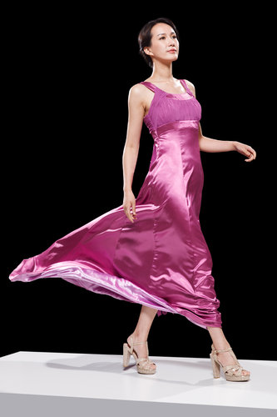
Distinct Features of Chinese Costume
Silk and the Silk Road
- Suzhou generally recognized home of Chinese silk
- The Silk Road, starting from the Weishui Valley and ending on
the east coast of the Mediterranean, introduced silk to the world

Silk Road Economic Belt
- based on the concept of the old silk road
- linking China with Central and Western Asia, as well as Europe
- regarded as the longest and most prospective economic belt
- boosts regional trade and economic development

Embroidery
- traditional Chinese handicraft
- features flowers, birds, scenery on silk or other cloth with
threads
- with regional and ethnic characteristics
- four most famous types: Sichuan embroidery, Suzhou
embroidery, Hunan embroidery, and Guangdong embroidery

Batik
- also known as wax printing
- popular among the Buyi, Miao and some other ethnic minority
groups
- can be made into garments, scarves, kerchiefs, bags, table
cloths, bedspreads, curtains, and other decorative items
Typical Chinese Costumes
Chinese Tunic Suit
- a uniform that Dr. Sun Yat-sen liked to wear and
recommended to the people of the country to wear
- with four pockets and a turndown collar, secured with five
central buttons

